Name: _____________________ Date: ______________________
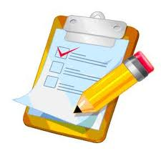
Student Checklist
Personal Writing Connection

1. What are three new things that you learned about our environment (positive and/or negative effects) and how does that make you feel? Explain using examples.

In my first paragraph… | Yes | No
I have consulted/used the article, “Canada’s Eco-Report Card”

I have clearly written 3 new things I have learned about how our environment is doing (positive and/or negative effects). Make sure to use examples from the article!

I have clearly written how these new discoveries make me feel and why

2. Based on your new learning discoveries, what kind of connections can you make to the “Canada’s Eco-Report Card” article?

In my second paragraph… | Yes | No
I have related/connected to at least 2 examples from the book “The Lorax” and 1 personal experience to the article, “Canada’s Eco-Report Card”.

Conventions:  Spelling, grammar, sentence structure, and organization | Yes | No
I have proof-read both my paragraphs
I have proper punctuation (capital letters, periods)
I have complete sentences
My paragraphs are well organized and flow nicely
I have used a dictionary and do not have any spelling mistakes

